Rules & Regulations

Eligibility
- Teams must consist of students from digital technology related backgrounds (IT, CS, Software Engineering etc). Both undergraduate and postgraduate students from any university are eligible, including double-degree students where at least one of their degrees is in IT or Computer Science related fields.
- Participation is open only to Malaysian citizens and foreign nationals who are currently studying at a university or educational institution in Malaysia.
- Judges, Mentors, Sponsors, and Organisers are not eligible to participate.

Participation

Teams of 2 to 5 members only.
- Team Participation Guidelines:
  - Switching members is prohibited unless approved by organizers:
    - Please contact Ming Dong (60 12-368 8837) for approval.
  - Once registered, participants should be able to sign into the website (https://averisxmonashhackathon2026.my).
  - Once the registration deadline has passed, team changes will no longer be allowed.
- Participants may form teams with members from different institutions.
- Each participant may only be a member of one team.
- If a participant is found to be registered or participating in more than one team, both teams will be disqualified from the competition.
- Registration to participate in Averis x Monash Hackathon 2026 is FOC.
- The platform used throughout the event will be in discord platform.
- Any kind of tampering with the competition’s registration, flow and/or result in any way will result in the participant/team being disqualified from Averis x Monash Hackathon.
- Any form of harassment, discrimination, or disruptive behaviour towards other participants, mentors, judges, or organizers will cause immediate disqualification.

Submission Guidelines
- The submitted solution must incorporate Artificial Intelligence (AI) Technology as a key component.
- All work on the project must be completed during the official duration of the hackathon.
- The submission and all its components must be the team's original work. While referencing existing solutions is permitted, direct plagiarism of ideas, code, or designs is strictly prohibited.
- Participants are not allowed to plagiarize the ideas, work, or submissions of other teams.
- All submissions must be made before the specified deadline. Any incomplete, illegible, misdirected, or late submissions will not be considered.
- Submissions that contain or promote dangerous, vulgar, offensive, indecent, illegal, racist, plagiarized, cruel, or fraudulent content—or that infringe on the rights or copyright of others—will cause immediate disqualification.

Submission Criteria

- Preliminary Round Requirements
  - At a minimum, your submission should be a low-code solution.

A semi-working prototype is strongly encouraged.

No-code submissions will not be accepted.
  - Slide deck, video demo and prototype link has to be submitted.
- Final Round Requirements
  - A working prototype is expected from the participants
  - The final submission should be an extension and improvement of your preliminary round entry.

AI Usage Requirement

All submissions must incorporate AI and utilize cloud infrastructure as part of the solution’s development, deployment or core functionality.

Solutions that do not meaningfully integrate cloud infrastructure may receive significantly reduced scores.

Technical Stack

- Teams are free to use any programming languages, frameworks, platforms, libraries, APIs, or development tools of their choice. There are no restrictions on the technical stack used to develop the project.
- While there are no limitations on the tools or technologies used, teams are encouraged to adopt a well-designed and appropriate software architecture that supports the functionality and objectives of their project.
- Teams are encouraged to consider both short-term implementation and long-term potential, including factors such as scalability, maintainability, extensibility, and the potential for further development beyond the hackathon.

Awards
- All awards and prizes must be shared among all team members as per their mutual agreement.
- Prizes are non-transfierable and can only be claimed by the designated winner(s).
- The judges' and organizers' decisions regarding the selection of winners are final and binding. No appeals, disputes, or reconsiderations will be entertained.

Liability
- The Averis x Monash Hackathon 2026 Organizing Committee reserves the right to modify the rules and regulations without prior notice. Participants hold the responsibility to constantly check on communication channels should there be any changes in the rules and regulations.
- The Averis x Monash Hackathon 2026 Organizing Committee reserves the right, at their sole discretion, to eliminate or disqualify any participants or teams regarded as being in breach of these rules and regulations.
- Participation of Averis x Monash Hackathon 2026 is at the participant’s sole risk. To the extent permitted by law, the Organizing Committee will not accept any responsibility for any damage, loss, liabilities, injuries, costs, expenses or claims suffered by participants or any third parties arising out of or in connection with the competition and/or accepting a prize.
- Participants are required to provide consent in the registration form for photographs, videos, and/or recordings taken during Averis x Monash Hackathon 2026 to be used for event documentation, publicity, promotional, and social media purposes.

Data Protection and Privacy
- Any personal information that participants share with Averis x Monash Hackathon 2026 will be kept secure and only used in line with these rules and regulations (such as participant identification) unless the consent has been given by the participant for specific purposes.

Data Sharing and Consent
- By participating in Averis x Monash Hackathon 2026, participants consent to submitting their resumes, which will be shared with event sponsors and partners for recruitment and networking purposes.
- Sponsors may use the resumes for talent scouting, internship or job opportunities, and other professional engagements. However, participants are not guaranteed an offer by submitting their resume.
- Averis x Monash Hackathon 2026 organizers will take appropriate measures to store and transmit resumes securely. Sponsors receiving resumes are expected to handle the information responsibly and in compliance with applicable data protection laws.

Intellectual Property
- Participants retain the intellectual property rights to their projects. However, by participating in Averis x Monash Hackathon 2026, teams grant the event organizers a non-exclusive, royalty-free license to showcase and promote their projects for marketing and educational purposes.

Judging Criteria

Evaluation Criteria Distribution

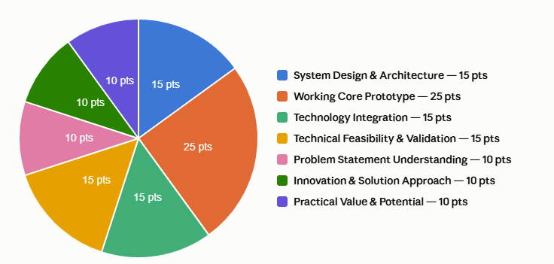

Evaluation Criteria Breakdown for Preliminary Round
Detailed version: Averis x Monash Hackathon 2026 Prelim Judging Criteria - Google Doc
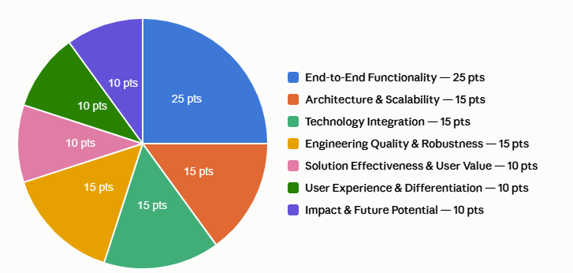

Evaluation Criteria Breakdown for Final Round
Detailed version: Averis x Monash Hackathon 2026 Final Judging Criteria

Submission

Submission Information
- Platform: Google Forms
- Submission Link: https://forms.gle/nnam5eXrf5cjXdf3
- Submission Period: 18th September 2026 - 22th September 2026 (12: 00 p.m.)

Submission Components
- Project Description (Mandatory)
  - Brief summary of the project, including its name, purpose and problem statement.

- Demo Video Link (Mandatory)
  - Overview of the project, showcasing its functionality.
  - Explaining key features and how technologies are integrated.
  - Demonstration of the working prototype.
  - The youtube video can be either unlisted or public. Private video will not be entertained.
  - Google drive links need to be shared as "Anyone with the link → Viewer".
  - Video should cover:
    - Quick Intro - Team name & project name
    - The Problem - Who it affects and why it matters
    - Tech Stack - Key technologies used
    - Live Demo - Walkthrough of your working prototype
    - Impact - Metrics, results, or user feedback
  - Maximum duration is 5 minutes
  - For every 30-second delay, 1 mark will be deducted.

- GitHub Repository Link (Mandatory)
  - Link to the project’s source code with a clear README file that includes setup instructions.

- Live Prototype / Demo Link (Mandatory)
  - Provide a publicly accessible link to the deployed project.
  - The deployment should be functional and accessible to the judges during the judging period.

- Slide Deck / Documentation Link (Mandatory)

  - Provide a publicly accessible link to slide deck or project documentation (e.g. Google Slides, PDF uploaded to Google Drive, Notion, GitHub README).
  - This should include:
    - Technical Architecture
    - Implementation Details
    - Challenges Faced
    - Future Roadmap

Google Forms Submission Structure

First Part: Team Details

- Team name
- Team representative details (name, email, contact number)

Second Part: Project Details

- Project Name
- Project Description / Summary
  - Brief summary of the project, including its purpose and the problem it aims to solve
- Github Repository Link
  - Public link to the project’s source code with a clear README containing setup instructions
- Live Prototype / Demo Link
  - Publicly accessible link to the deployed and functional project
- Slide Deck / Documentation Link
  - Public link to the project’s slides or documentation covering the technical architecture, implementation details, challenges, and future roadmap
- Video Demo Link (Maximum 5 mins video)
  - Demonstrates a working application and how a user will interact with the solution

